Prayer Walk—International Student Ministry Equipping Conference May 23-25 2023
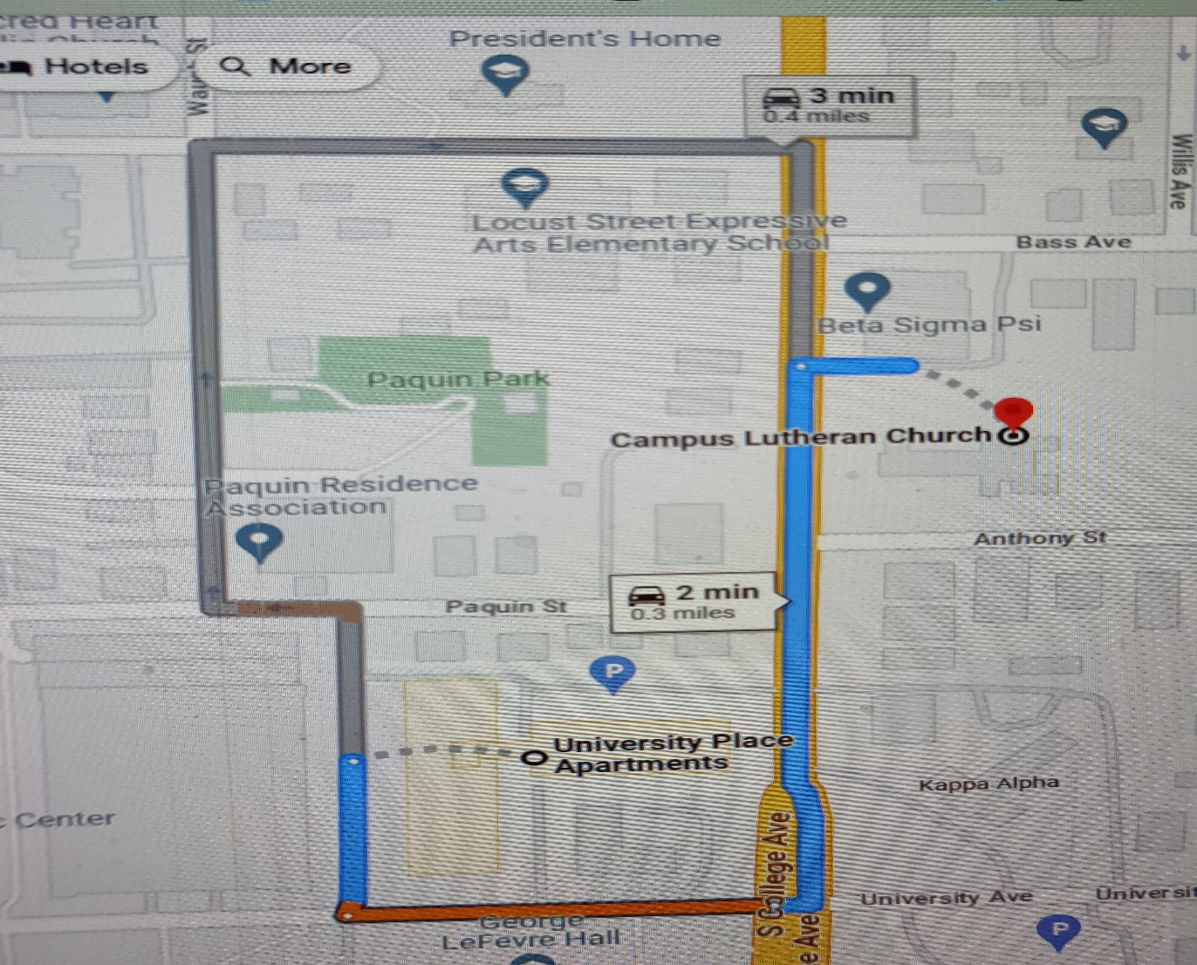

Thank you for participating in this prayer walk.
As you exit the building you will turn left and walk down to College Ave. From there you will turn left and walk south a block and a half, crossing Anthony St. and going up to the stop light at University Ave. Turn right at the stop light, pressing the crosswalk button to get the signal to give you the right to cross. You have 20 seconds to make it across the intersection. You will proceed west past the University Place Apartments on your right. Turn right on Matthews St. Turn right on Paquin St. Turn right on College Ave and back up to University. Cross the street and walk back to Campus Lutheran.
If you are driving you will turn left on Paquin, ( Paquin is a one way street.) right on Waugh and right on Locust street to get back to College Ave. Then turn left back into the church parking lot.
If you are driving, you may want to add prayers for those with disabilities and older adults who live in Paquin Towers. As you go up Locust St. you may wish to pray for the students at Locust Elementary.

As you leave the building—
Ask the Holy Spirit to have “the peace of God, which transcends all understanding, will guard your hearts and your minds in Christ Jesus.” Philippians 4:7,
Use the following scripture to guide your time of prayer over our international students and families that have been invited to join our conference for an evening of language learning games. This will include an invitation to our Care & Share area, our Friday morning language class, VBS and Sunday Morning service and education hour.
Scriptures as you walk from the church to Anthony Street

1 Thessalonians 5:16-18 ¹⁶ Rejoice always, ¹⁷ pray continually, ¹⁸ give thanks in all circumstances; for this is God’s will for you in Christ Jesus.
1 Timothy 2:4-6 ⁴ God wants everyone to be saved and to fully understand the truth. ⁵ There is only one God, and there is only one way that people can reach God. That way is through Christ Jesus, who as a man ⁶ gave himself to pay for everyone to be free. This is the message that was given to us at just the right time.
Scriptures for Anthony St to University Ave.
Matthew 28:18-20 ¹⁸ So he came to them and said, “All authority in heaven and on earth is given to me. ¹⁹ So go and make followers of all people in the world. Baptize them in the name of the Father and the Son and the Holy Spirit. ²⁰ Teach them to obey everything that I have told you to do. You can be sure that I will be with you always. I will continue with you until the end of time.”
Ask the Holy Spirit to be sent and to knock on the doors of their hearts.
Revelation 3:20
Here I am! I stand at the door and knock. If anyone hears my voice and opens the door, I will come in and eat with that person, and they with me.

Scriptures for walking down University Ave
And for God to answer our prayers and meet the needs of those He sends to us.
Numbers 6:26
May the Lord answer your prayers and give you peace.’
1 Kings 8:43
From your home in heaven, please listen to their prayers. Please do everything the people from other places ask you. Then they will fear and respect you the same as your people in Israel. Then all people everywhere will know that I built this Temple to honor you..
Psalm 65:5
God, you answer our prayers and do what is right. You do amazing things to save us. People all over the world know they can trust in you, even those who live across the sea.
Scriptures for walking Matthews ST.
Psalm 145:19
He listens to his followers and does what they want. He answers their prayers and saves them.
Ephesians 6:18
Pray in the Spirit at all times. Pray with all kinds of prayers, and ask for everything you need. To do this you must always be ready. Never give up. Always pray for all of God’s people.
Scriptures for walking Paquin Ave.
Revelation 8:3
Another angel came and stood at the altar. This angel had a golden holder for incense. The angel was given much incense to offer with the prayers of all God’s holy people. The angel put this offering on the golden altar before the throne

Isaiah 56

All Nations Will Follow the Lord
The Lord said these things, “Be fair to all people. Do what is right, because soon my salvation will come to you. My goodness will soon be shown to the whole world. I will bless those who refuse to do wrong and who obey the law about the Sabbath.” Some foreigners will choose to follow the Lord. They should not say, “The Lord will not really accept me like the rest of his people.”

Scriptures as you walk College Ave,
Exodus 23:9
“You must never do wrong things to a foreigner. Remember, you know what it is like to be a foreigner because at one time you were foreigners in the land of Egypt.
Deuteronomy 31:12
Bring together all the people—the men, the women, the little children, and the foreigners living in your cities. They will hear the teachings, and they will learn to respect the Lord your God. Then they will be able to do everything in this Book of Teachings.
Zechariah 8:23
The Lord All-Powerful says, “At that time many foreigners speaking different languages will come to a Jewish man, take hold of the hem of his robe, and ask, ‘We heard that God is with you. Can we come with you to worship him?’”

